1. Parenthesis will prevent file-based routing

 This is called route group which help us organize our files without affecting URL structure

1. Nested layout structure

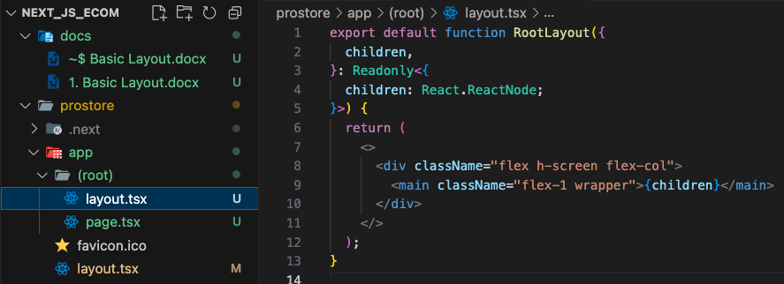

* We created a new layout and transferred our main page to the root group to use this layout.

1. Dynamic metadata

We added the template to use the DRY principle. We are taking everything from a constant file which is then taking from env file. The new URL is needed to create a valid URL.

1. Preventing lazy loading on images

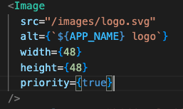

By default, to optimize performance, next js implements lazy loading. But some images like out main logo might be critical so we prevent it by adding priority.

1. As child

without as child, we would have end up with

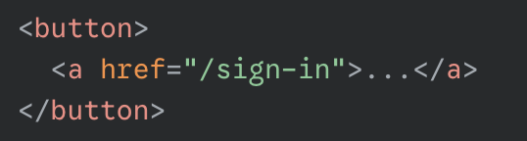

* But with the help of as child, we get:  directly as the final rendered html. So, we can use the beautiful design of button without compromising.